**LIBRARY MANAGEMENT SYSTEM**

**Goal:**

This Is a library management system built using php. The system is a perspective of librarian and not a borrower.

**Functional Description:**

|  |
| --- |
| This project aims at building a library system which allows the librarian  to search for books, checkin books, pay fine, checkout books, check history of a borrower and also to  create a new user and issue a card no.  **User Interface**:  Initial Page: |
|  |

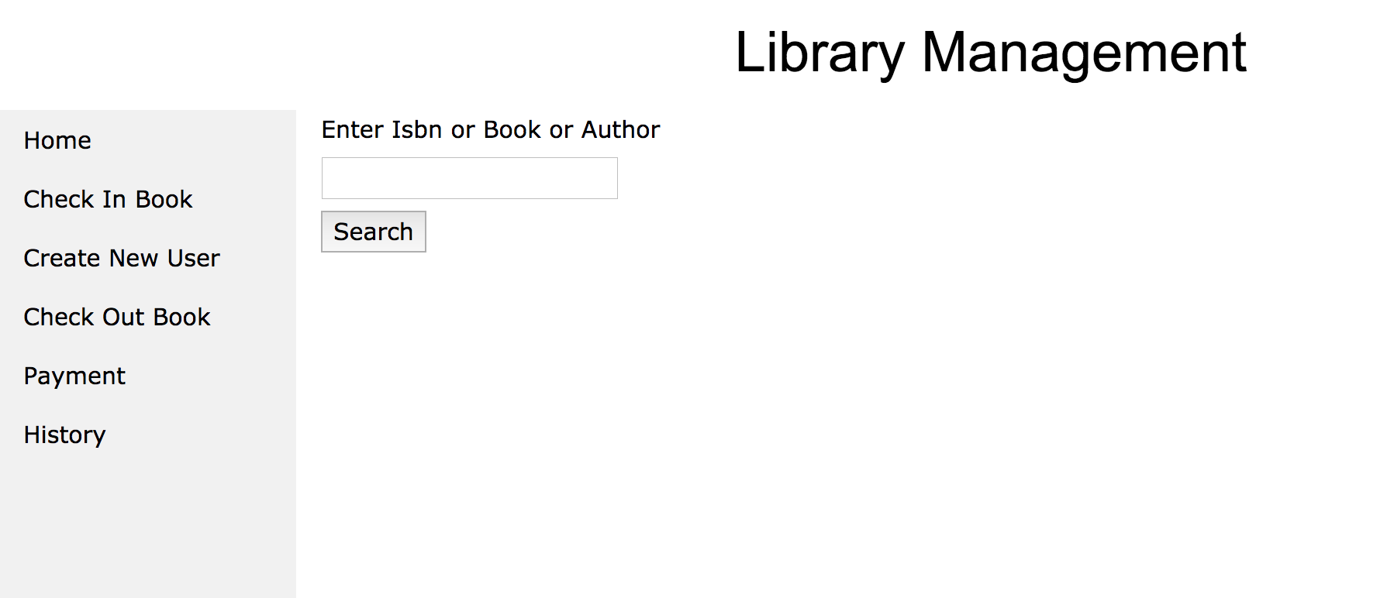

Enter the substring or isbn or author

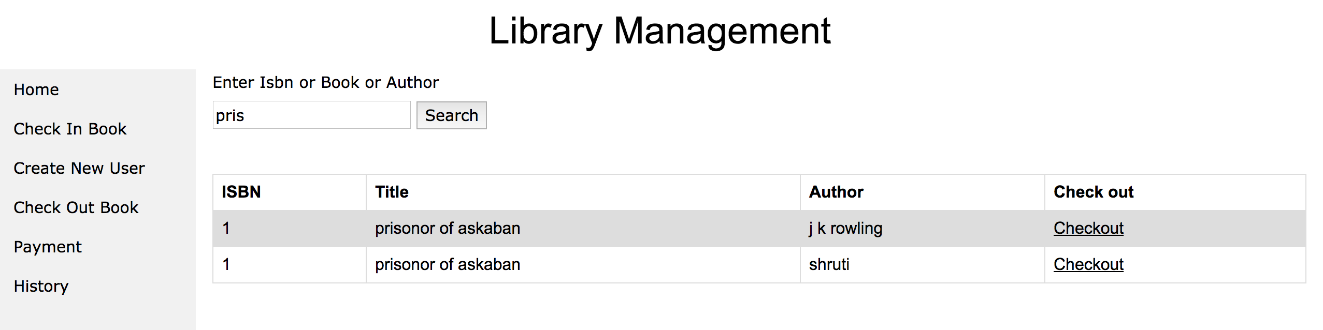

User can check out the desired book using the check out link or entering the isbn and card no in checkout page

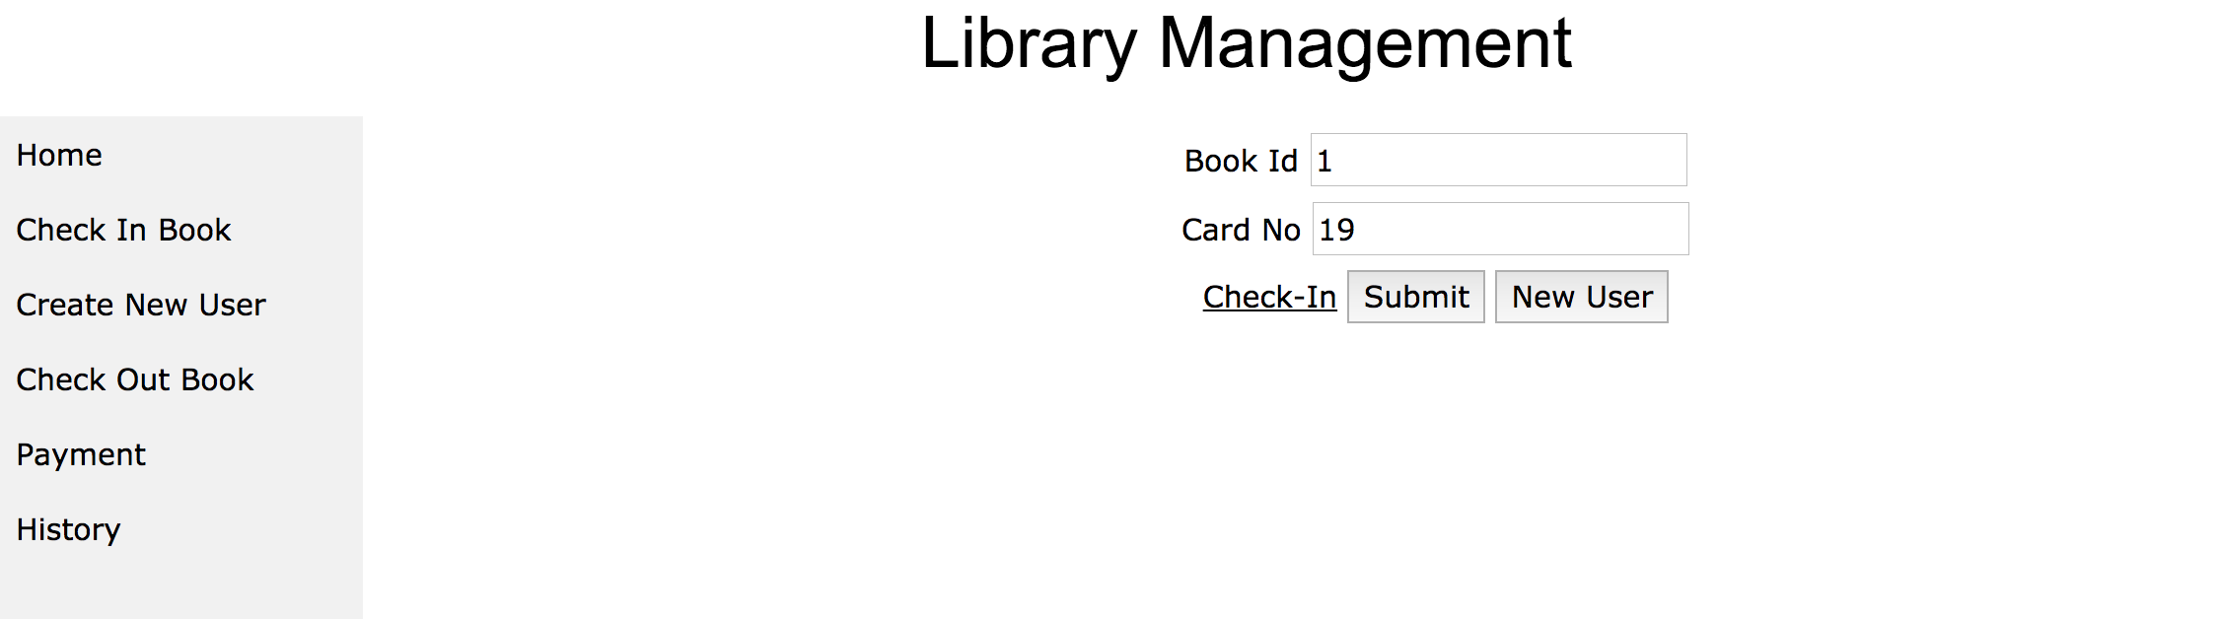

On success the message book issued will appear.

To checkin enter the card no of the user and select the books to check in then click on check in.

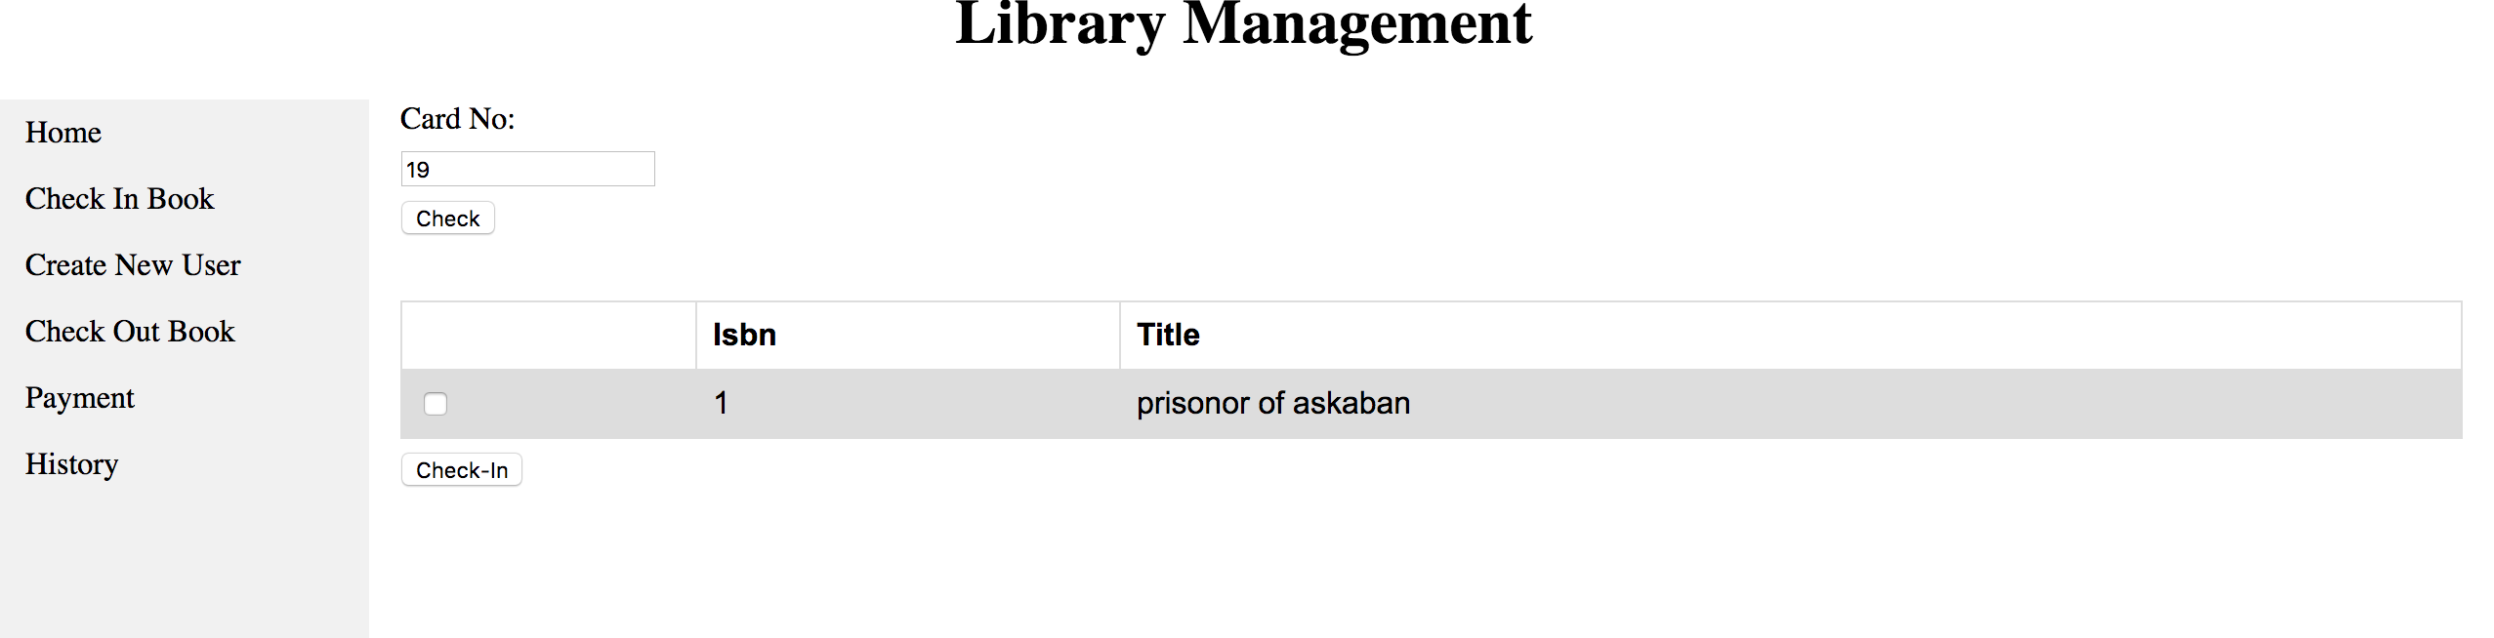

On the payment page enter the card no and check the total dues

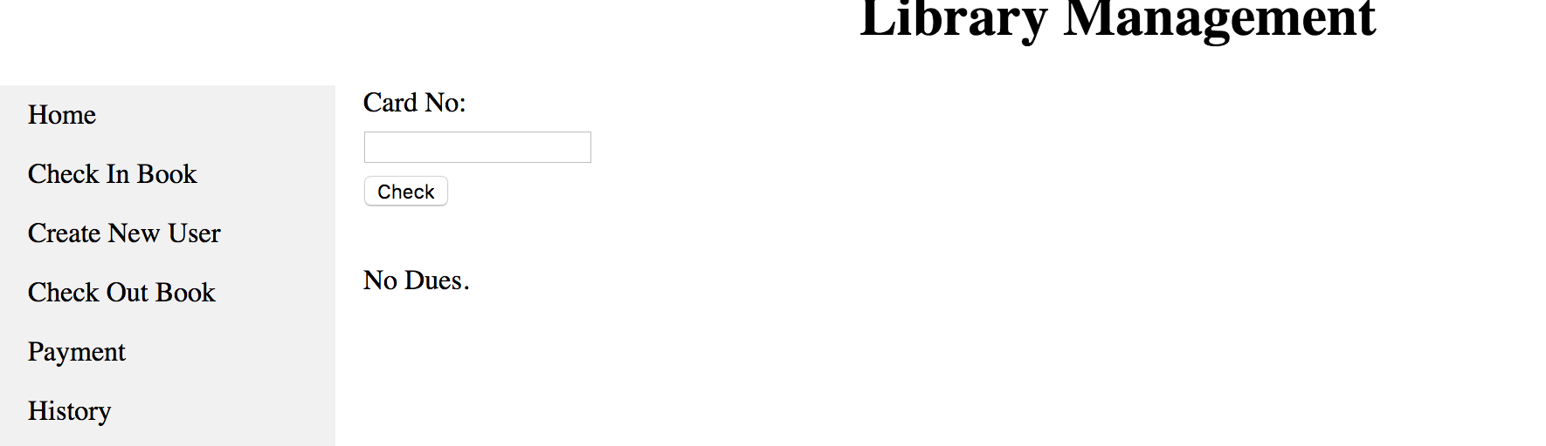

On the history page with card no one can see the history of books issued, amount paid and dues.

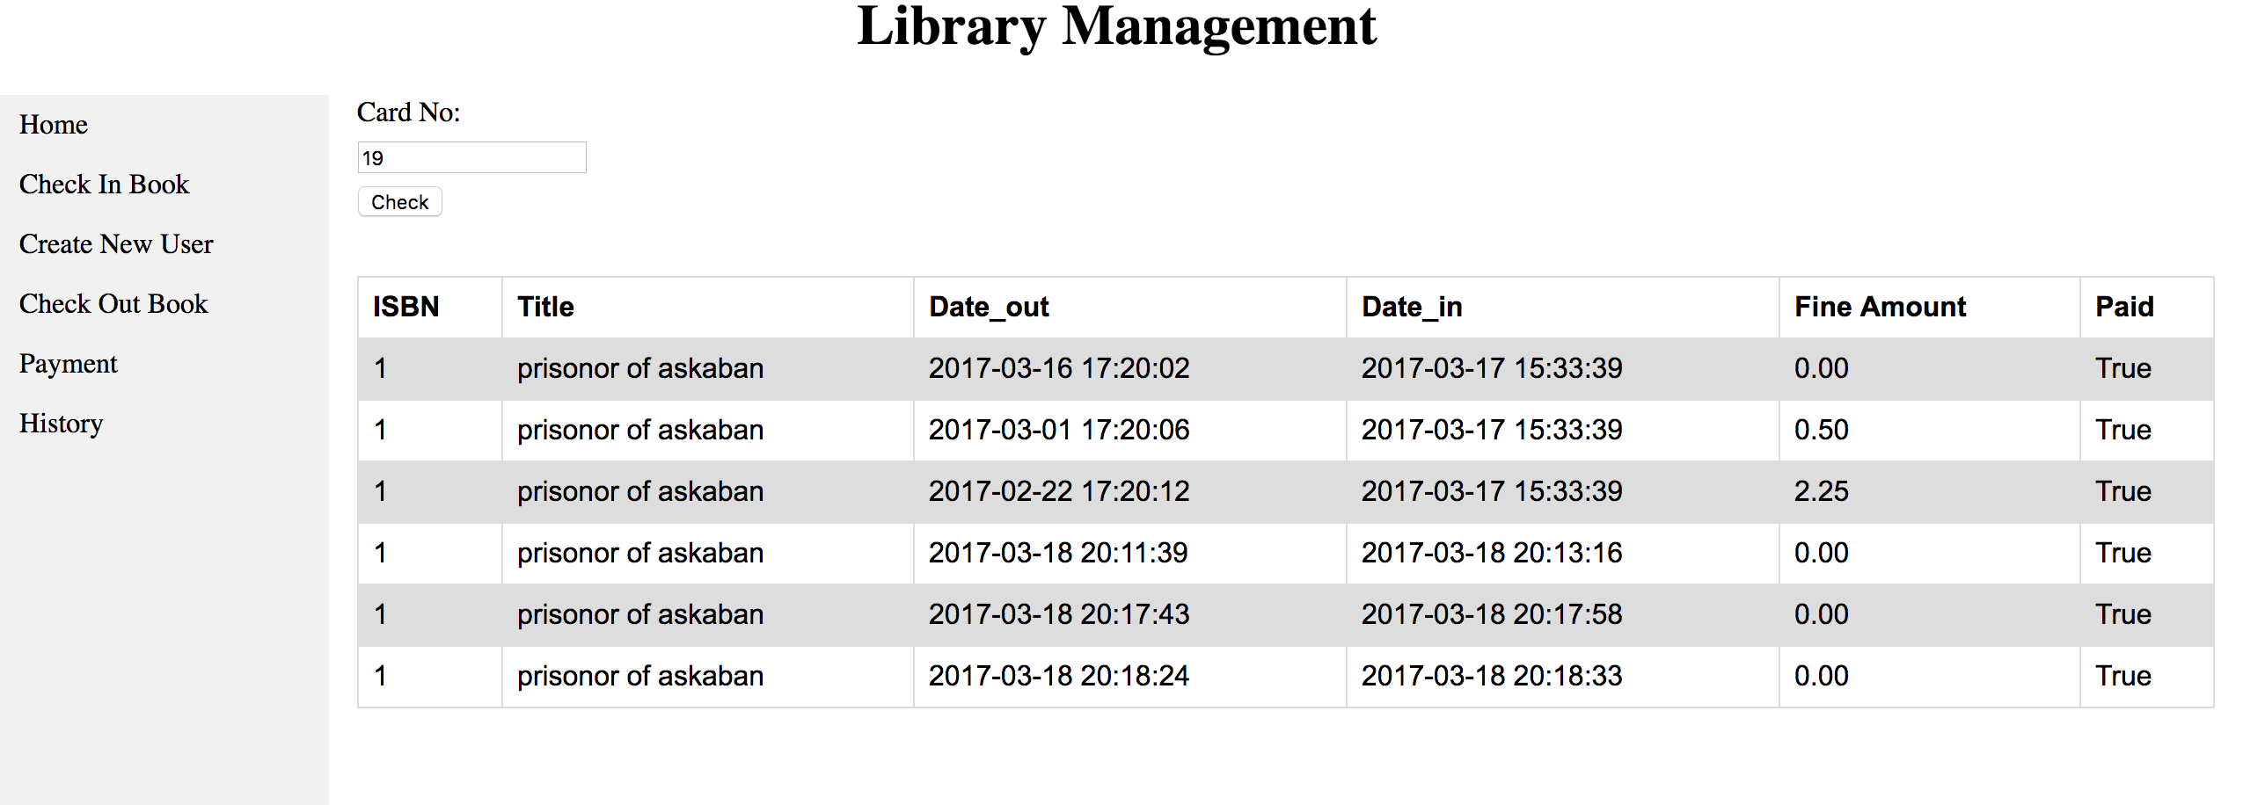

**Data Cleanup:**

A tool called CSVed (http://csved.sjfrancke.nl/) was used to clean up data files from all the special characters. Separated the data using import option in MSExcel and also few data’s(Chinese characters) were cleaned manually.

**Technical Dependencies:**

* **MAMP 4 KIT (INCLUDES PHP MYSQL)**
* **PHP, CSS, HTML**